**Set-Var Step Document**

**Objective:**

Store the value into a variable.

**Concepts:**

1.java.util.Base64 class is used to encode or decode the data.

**Set-Var Step Json:**

{

"workflows": [

{

"name": "set-var",

"id": 200,

"trigger": "rest",

"expression": "setvar/{table_name}",

"method": "GET",

"steps": [

{

"type": "start",

"id": 1,

"next": {

"start": "set-var-start"

}

},

{

"plugin_name": "set-var",

"value": "select * from ${request.path.table_name}",

"value_type": "ftl",

"output_variable": "set-var-output",

"type": "sql",

"id": "set-var-start",

"next": {

"success": "sql-success",

"failure": "hangup"

}

},

{

"value": "set-var-output",

"value_type": "ftl",

"name": "set-var-name",

"encode_or_decode": "encode",

"char_set": "utf-16",

"type": "set-var",

"id": "sql-success",

"next": {

"success": "set-var-success",

"failure": "hangup"

}

},

{

"variable_name": "set-var-name",

"http_response_code": "200",

"response_content_type": "text/html",

"value_type": "hb",

"type": "send",

"id": "set-var-success",

"next": {

"success": "hangup",

"failure": "hangup"

}

}

]

}

],

"filters": [],

"server": {},

"plugins": [

{

"id": 243,

"name": "set-var",

"type": "mysql-plugin",

"version": "1.0",

"category": "Database",

"server": "training.cketk3dxfvdd.us-east-1.rds.amazonaws.com",

"username": "appup",

"password": "Appup123",

"schema": "RAJNISH_CONTACTS"

}

]

}

**Set-Var Step Attributes Description:**

|  |  |
| --- | --- |
| **Attributes** | **Description** |
| **1.name** | Name represents the name of the set-var |
| **2.value** | Value holds the data of the set var. |
| **3.value_type** | Value_type represents the type of the value. |
| **4.encode_or_decode** | Encode_or_decode attribute contains three values Encode,Decode and Do_nothing. Encode converts data into encoded format.  Decode converts data into decoded format.  Do_nothing is cannot perform anything on data. |
| **5.char_set** | Specifies type of the character set. Based on char_set type data is converted into sequence of bytes. |

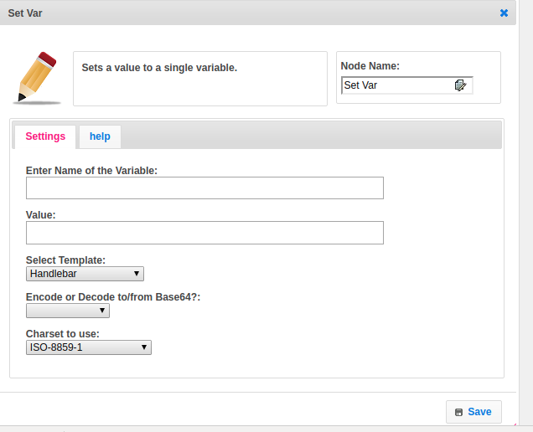

**Set-Var Step Execution Flow:**

**Logic:**

Checks the value attribute contains data or not, if it contains the data again it checks the encode_or_decode attribute contains any info or not. If encode_or_decode have data provided by user,based on data by using java.util.Base64 class data is converted to encode or decode. Encode_or_decode value is Do_nothing then it will not converted into any other format.

Finally put into map name as key and value as value.